**T02 – Micro Controller State Diagram**

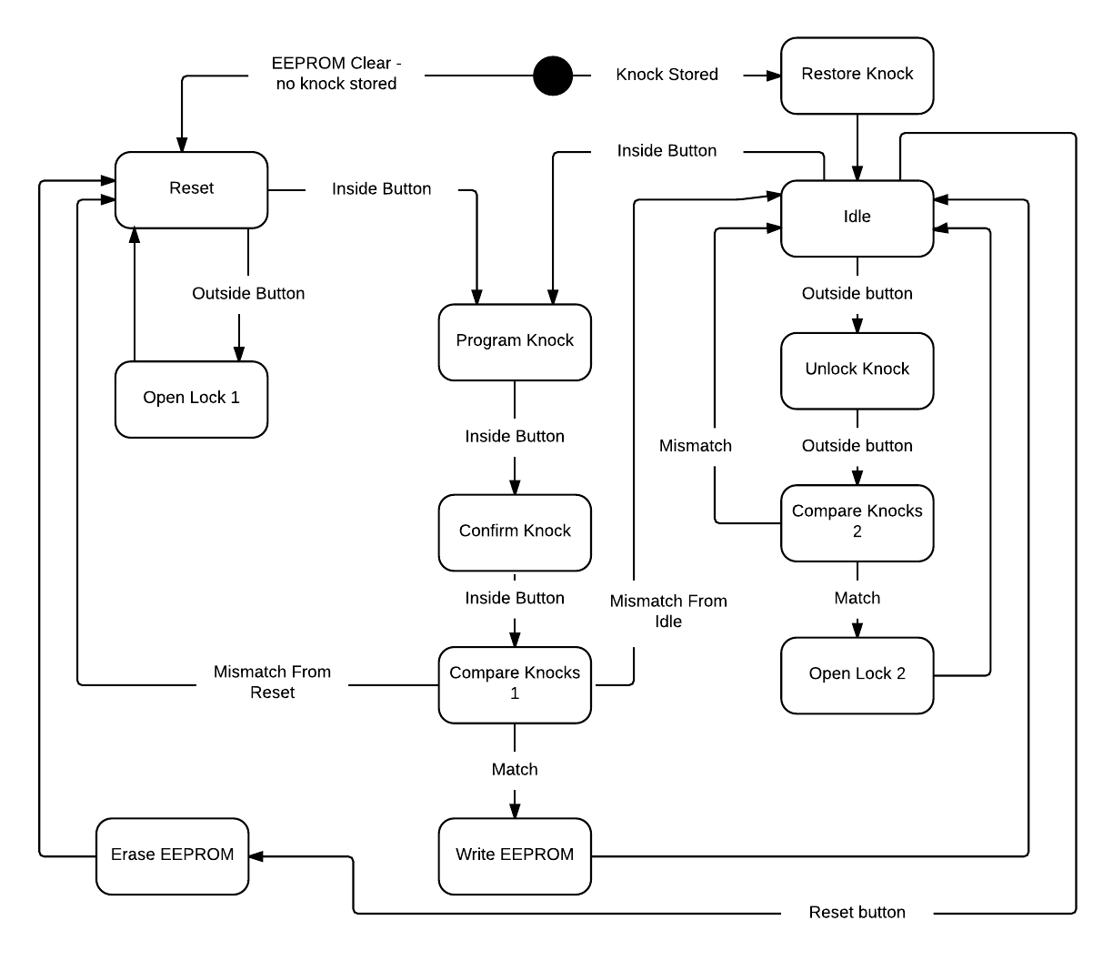

**State Table/Description**

|  |  |  |  |
| --- | --- | --- | --- |
| **State** | **Inputs** | **Outputs** | **Function** |
| Reset | - Outside button  - Inside button | - Red LED on  - Green LED off  - Solenoid closed | No current knock is stored. Allows for the door to be opened without inputting a knock. |
| Open Lock 1 | - None | - Red LED off  - Green LED on  - Solenoid open | Opens the lock for 5 seconds and turns the green LED on to signal that the door is open. Returns to reset after 5 seconds. |
| Program Knock | - Inside button  - 5V analog ADC “knock” value | - Red LED on*  - Green LED on*  - Solenoid closed | Checks the ADC value for a knock (defined as a value above a certain thresh hold). Stores the time of each knock in milliseconds. When the inside button is pressed, the sequence is over. |
| Confirm Knock | - Inside button  - 5V analog ADC “knock” value | - Red LED on*  - Green LED on*  - Solenoid closed | Briefly, only the green LED is on to signal that the knock was recorded and now the user must confirm their knock. This function does exactly what Program Knock does, recording the sequence to a new area. |
| Compare Knocks 1 | - Program sequence and confirm sequence | - If records match, green LED on  - If no match, red LED on  - Solenoid closed | Compares the program knock and the confirmation knock. If the knocks fall within a certain thresh hold of each other, the knocks match. If they do not match, return to either reset or idle, depending on which one entered the program state. |
| Write EEPROM | - Program knock sequence | - Red LED off  - Green LED on  - Solenoid closed | Writes the newly programmed knock sequence to EEPROM in case the micro controller loses power. |
| Restore Knock | - None | - Red LED on  - Green LED off  - Solenoid closed | Restores a knock sequence from EEPROM after a micro controller restart. |
| Idle | - Inside button  - Outside button  - Reset button | - Red LED on  - Green LED off  - Solenoid closed | Sits idle and waits for one of the three buttons to be pushed |
| Unlock Knock | - Outside button  - 5V analog ADC “knock” value | - Red LED on*  - Green LED on*  - Solenoid closed | Much like Program Knock, listen for an ADC knock value above the thresh hold and record the time. When the outside button is pressed, the sequence is done. |
| Compare Knocks 2 | - Programmed knock sequence and unlock sequence | - Red LED on  - Green LED off  - Solenoid closed | Compare the programmed sequence to the unlock sequence in the same way as compare knocks 1. If the knock times fall within a thresh hold of each other, the box is opened. |
| Open Lock 2 | - None | - Red LED off  - Green LED on  - Solenoid open | Opens the lock for 5 seconds and turns the green LED on to signal that the door is open. Returns to idle after 5 seconds. |
| Erase EEPROM | - None | - Red LED on  - Green LED off  - Solenoid closed | Erase the programmed knock sequence in EEPROM and return to reset. This is a debugging feature only. |

* We are using a bi-colored LED. Having green and red on at the same time creates yellow.